Superstore Sales Analysis Report

Project: Superstore Sales Analysis
Intern: Prem Pandey
Organization: Alfido Tech
Dataset: Superstore Sales Dataset
Date: June 2026

Objective
The objective of this project is to analyze Superstore sales data to identify sales trends, regional performance, top-performing products, and business opportunities. The analysis includes data cleaning, KPI calculations, visualizations, and actionable recommendations.
Dataset Overview :-
Dataset Information
- Total Records: 9800
- Total Columns: 18
- Data Source: Kaggle Superstore Sales Dataset
- Link: https://www.kaggle.com/datasets/bhanupratapbiswas/superstore-sales
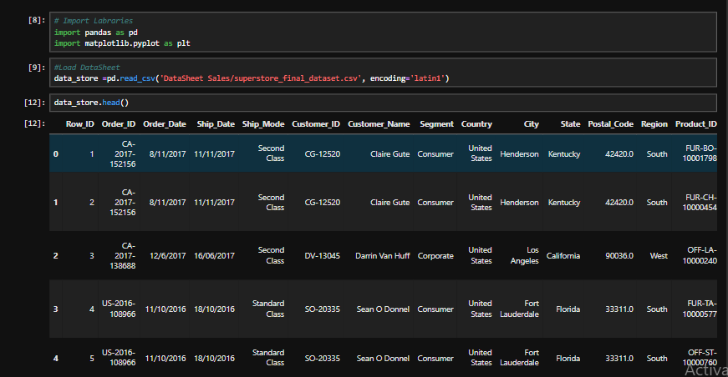

Data Cleaning
The following data-cleaning steps were performed:
- Checked for missing values.
- Removed duplicate records.
- Verified data types.
- Converted Order Date into DateTime format.
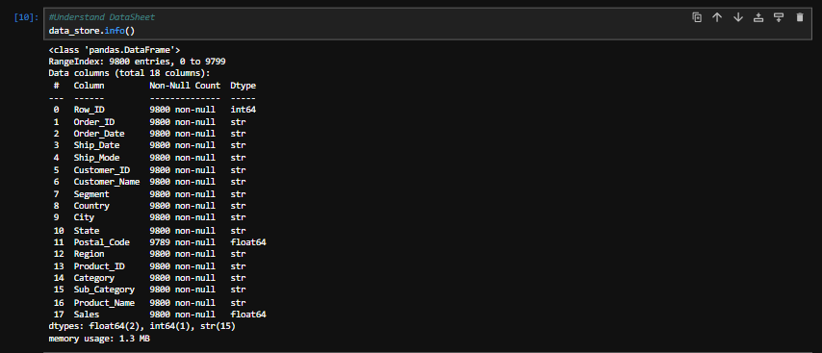
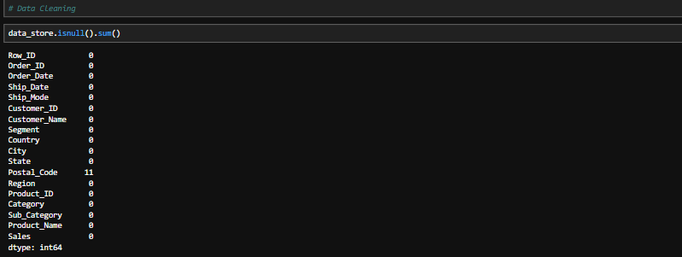

KPI Analysis

Key Performance Indicators
KPI | Value
Total Revenue | 2252607.4127
Total Orders | 4916
Average Order Value | 458.2195713384866
Profit Margin | Not Available
Conversion Metric | Not Available
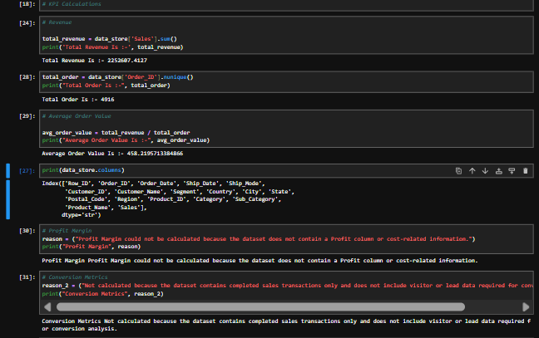

Sales Performance Analysis

Regional Sales Analysis
This chart shows revenue generated by each region.
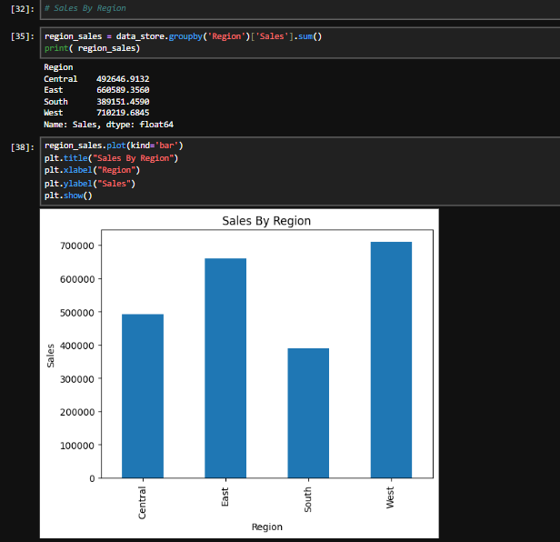

Category-wise Sales Analysis
This chart compares sales across product categories.
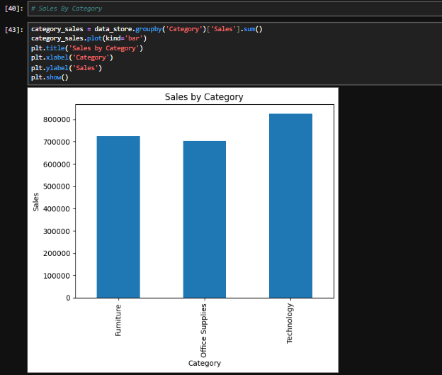

Top 10 Products
This analysis identifies the highest revenue-generating products.
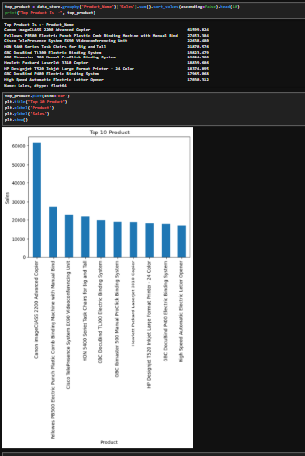

Lowest Performing Products
This analysis identifies products contributing the least revenue.
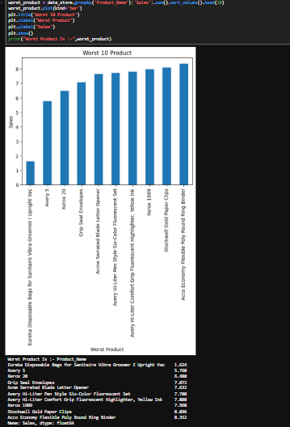

Time Trend Analysis
Monthly sales trends were analyzed to identify seasonal patterns and peak sales periods.
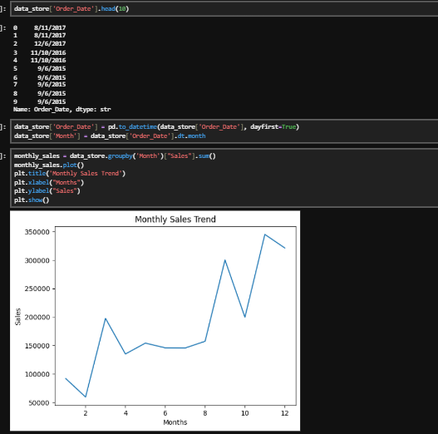
Write after seeing your graph:
- Highest sales month: November
- Lowest sales month: Feburary
- Seasonal trend observed: Sales fluctuated throughout the year, with peak sales observed in November and lower sales in February, indicating seasonal demand patterns.
Key Findings
Example:
- The West region generated the highest revenue.
- Technology category achieved maximum sales.
- Certain products contributed significantly to total revenue.
- Monthly sales showed seasonal fluctuations.
- Some products consistently underperformed.

Recommendations

5 Tactical Improvements
- Increase marketing efforts in high-performing regions.
- Promote top-selling products through bundle offers.
- Review and optimize inventory for low-performing products.
- Launch promotional campaigns during peak sales seasons.
- Use customer segmentation for targeted marketing.

Conclusion
The analysis provided valuable insights into sales performance, customer demand, and product trends. The findings can help improve revenue generation, inventory planning, and sales strategies.

GitHub Link
https://github.com/PremPandey9/Sales-Performance-Analysis

